APK Changes Recommended
- Firstly Congratulations for this. Great achievement.

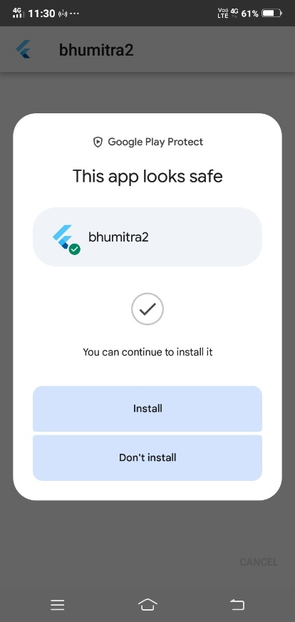

- Secondly, on Home Screen the Page is neither fully opening touching nor creating a black bg header, its getting quite messy.

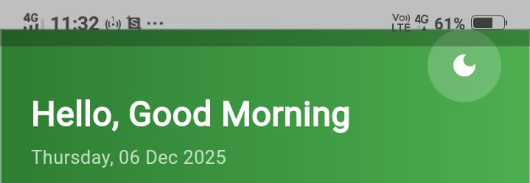

- Thirdly, the date is not updating on HomeScreen. (Recommendation: Wether Report can be on the home screen to be more generalize form (W)

Weather Block

- Change the icons of these two things: From Dollar to Rupee Sign(since it is focused on India) and From Leaf to Seed(Since we are selling seeds not saplings, and u can use coffee bean as an icon of Seeds or whatever you do would be appreciated).
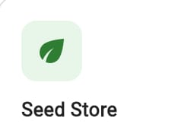
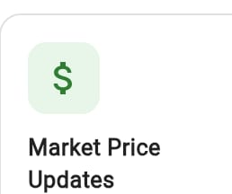

- Weather Insights: The Units aren’t in the proper manner, they are correct but the placement of them isn’t correct. Also keep the Fehrenhot Scale as well, though in India, people widely use Celsius scale only but still.
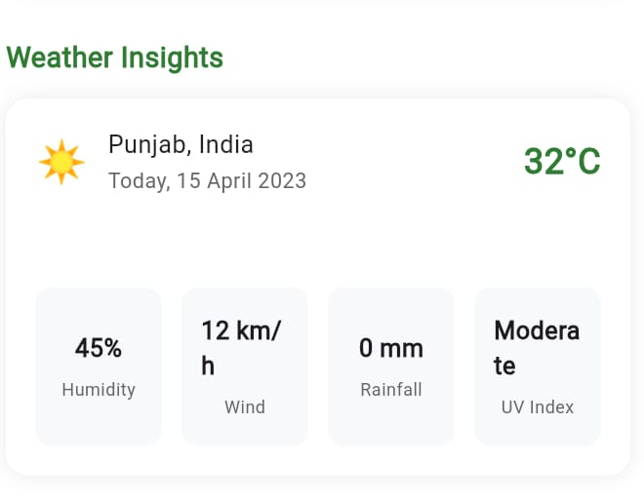
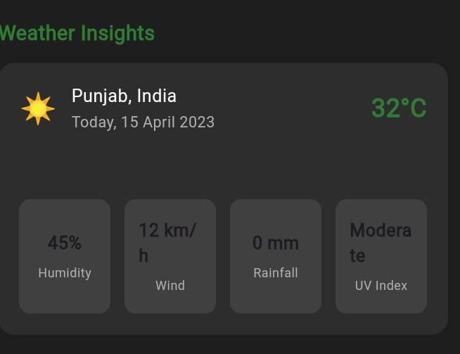
- Dark Mode issue: By turning on Dark Mode the visibility issue is coming up, user is not able to visualize this properly.
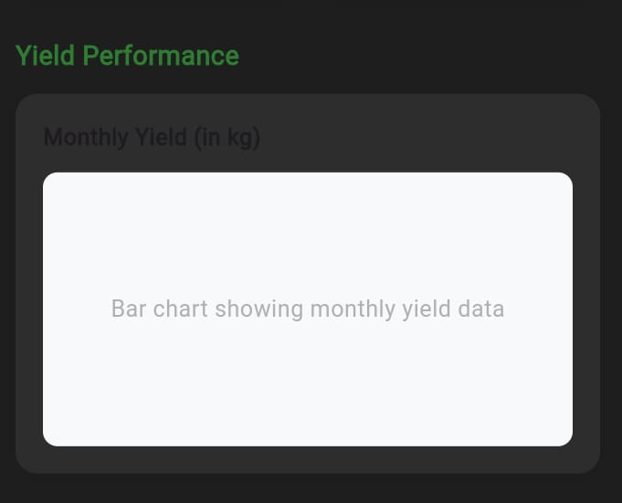

- I don’t know what is this

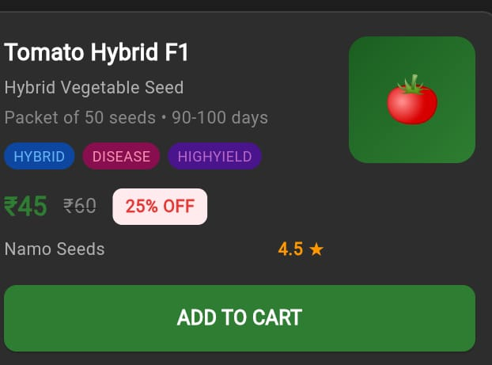
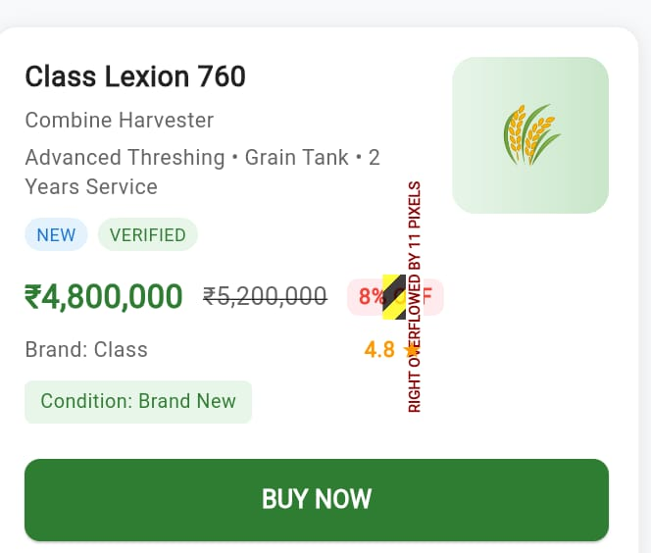
- Original Prices are poorely visible and discounts are more visible in the board.

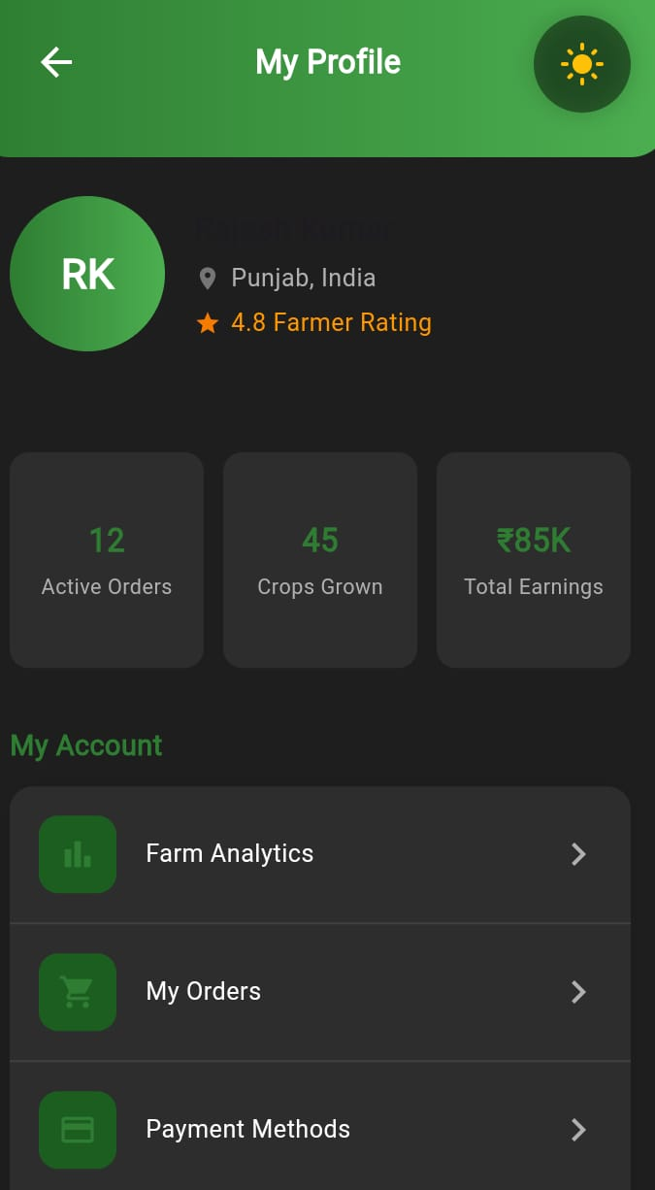
- Green Shade is not proper visible, icons are hard to visible in Dark Mode.

- Selection of Seasons, colours are not visible clearly.
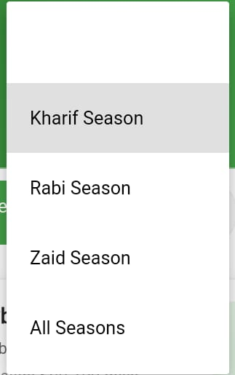
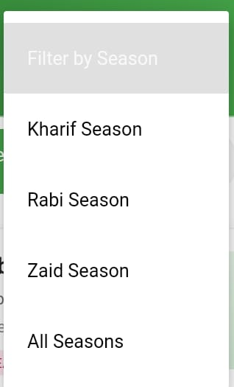

- I don’t even know this
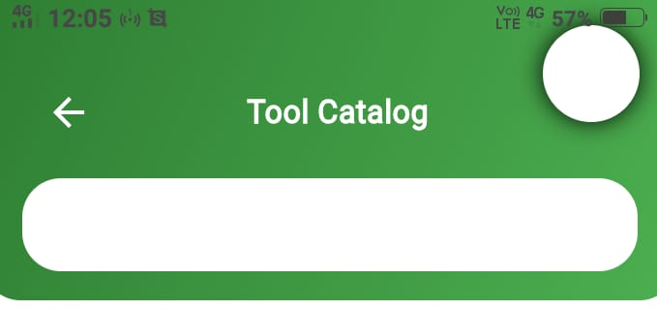

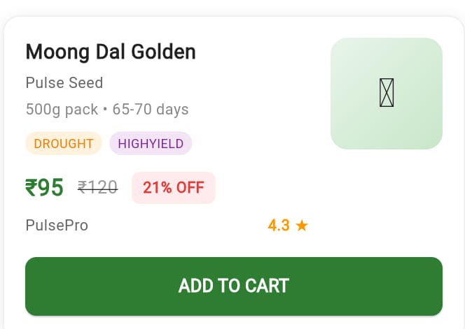
- Icons aren’t visible in this

